**Project Design Phase**

**Solution Architecture**

|  |  |
| --- | --- |
| Date | 28 June 2025 |
| Team ID | LTVIP2025TMID59160 |
| Project Name | Citizen AI – Intelligent Citizen Engagement Platform |
| Maximum Marks | 4 Marks |

**Solution Architecture:**

Solution architecture is a complex process – with many sub-processes – that bridges the gap between business problems and technology solutions. Its goals are to:

* Find the best tech solution to solve existing business problems.
* Describe the structure, characteristics, behavior, and other aspects of the software to project stakeholders.
* Define features, development phases, and solution requirements.
* Provide specifications according to which the solution is defined, managed, and delivered.

**Example - Solution Architecture Diagram**

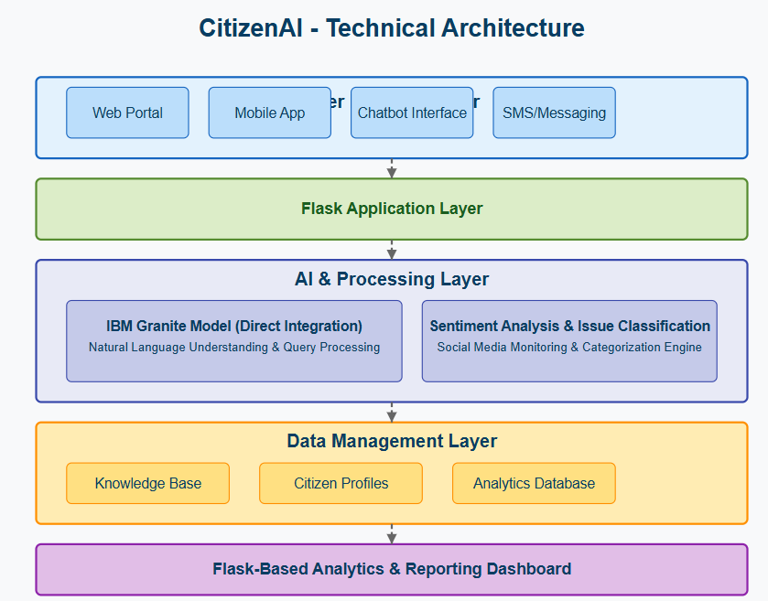

*Figure 1:* **Citizen_AI *Technical Architecture***

1. User Layer

This is the top layer where citizens interact with the AI.

Web Portal: A website that users can visit and ask questions.

Mobile App: A mobile version of the AI chatbot.

Chatbot Interface: A chat window where you type your question and get answers.

SMS/Messaging: Option to interact using text messages.

2. Flask Application Layer

This is the middleman that connects what the user types to the smart AI engine.

Flask is a Python tool used to build the app and handle user requests.

It takes your message and passes it to the AI model, then brings back the answer to show on your screen.

3. AI & Processing Layer

This is the “brain” of CitizenAI.

IBM Granite Model: A powerful AI engine that understands questions and gives intelligent answers.

Sentiment Analysis & Issue Classification: It can detect if users are happy, sad, or frustrated. It also organizes questions into categories (e.g., jobs, health, education).

4. Data Management Layer

This layer stores and organizes important information that the AI uses.

* **Knowledge Base**: Stores answers, government schemes, and FAQs.
* **Citizen Profiles**: Optional information about users (like preferences, areas of interest).
* **Analytics Database**: Saves feedback, questions, and mood (sentiment) data to study trends.

5. Flask-Based Analytics & Reporting Dashboard

This is the **report card** of CitizenAI.

* Shows how many people asked questions, what they asked, and what their mood was.
* Helps government or organization staff understand public opinion and common issues.
* Useful charts and graphs make the data easy to understand.